Project Design Phase-II
Technology Stack (Architecture & Stack)
Date | 28 September 2026
Team ID | SWTID-2026-4440
Project Name | Auto Ticket Classification using Flow Designer
Maximum Marks | 4 Marks
Technical Architecture:
The Deliverable shall include the architectural diagram as below and the information as per the table1 & table 2
Example: Auto Ticket Classification using Flow Designer
Reference: https://www.servicenow.com/docs/bundle/zurich-application-development/page/build/flow-designer/concept/flow-designer.html
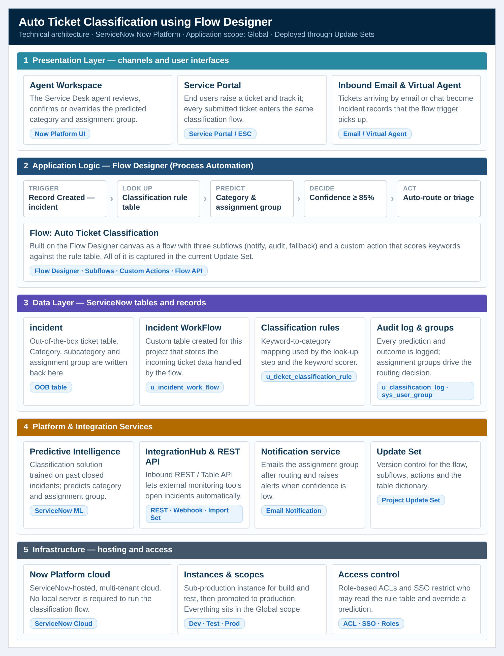
Figure 1. Technical architecture of the Auto Ticket Classification solution — five layers from the agent-facing interfaces down to the ServiceNow cloud infrastructure, with Flow Designer at the centre of the application logic.
Table-1 : Components & Technologies:
S.No | Component | Description | Technology
1 | User Interface | How the user interacts with the application — agent workspace, self-service portal and virtual agent | ServiceNow Agent Workspace; Service Portal; Virtual Agent (Now Platform UI)
2 | Application Logic-1 | Logic that classifies an incoming ticket and routes it to the correct group | ServiceNow Flow Designer — flow “Auto Ticket Classification”
3 | Application Logic-2 | Reusable automation steps shared across flows | Flow Designer Subflows (notify, audit, manual-triage fallback)
4 | Application Logic-3 | Custom scoring logic used when the ML model cannot decide | Flow Designer Custom Action + Script step (JavaScript, GlideRecord)
5 | Database | Data type and configuration — the tables the flow reads and writes | ServiceNow tables: incident (OOB), u_incident_work_flow (custom), u_ticket_classification_rule, u_classification_log
6 | Cloud Database | Database service on cloud | ServiceNow Cloud — Now Platform instance database (no external DB required)
7 | File Storage | File storage requirements — attachments added to a ticket | ServiceNow Attachment table (sys_attachment), stored on the Now Platform cloud
8 | External API-1 | Purpose of the external API used to create tickets and request a prediction | ServiceNow REST / Table API (inbound); Predictive Intelligence API (sn_ml)
9 | External API-2 | Purpose of the external API used for notification and collaboration | IntegrationHub REST step — SMTP email and Microsoft Teams notification
10 | Machine Learning Model | Purpose of the Machine Learning model — predict Category, Subcategory and Assignment group, with a confidence score | ServiceNow Predictive Intelligence — classification solution trained on historical closed incidents
11 | Infrastructure (Server / Cloud) | Application deployment on local system / cloud  Local Server Configuration: none — the platform is SaaS only  Cloud Server Configuration: ServiceNow Now Platform, multi-tenant cloud, Global application scope, Dev → Test → Prod instances | ServiceNow Cloud; Update Sets for promotion between instances
Table-2: Application Characteristics:
S.No | Component | Description | Technology
1 | Open-Source Frameworks | List the open-source frameworks used | None required — the solution is built entirely on the ServiceNow platform. JavaScript (Rhino engine) inside Flow Designer Script steps; REST / JSON for integration. The Now Platform UI Framework can be used if a custom React widget is added.
2 | Security Implementations | List all the security / access controls implemented, use of firewalls etc. | Role-based Access Control and table-level ACLs on u_incident_work_flow and the rule table; SSO / SAML and multi-factor sign-on; TLS 1.2+ in transit and encryption at rest on the platform; audit logging of every classification and override; IP allow-list on the inbound REST endpoint.
3 | Scalable Architecture | Justify the scalability of architecture (3-tier, micro-services) | Tiered ServiceNow architecture (presentation / logic / data) delivered as a multi-tenant SaaS service. Flow Designer executes asynchronously off the insert transaction with queued and parallel execution, so throughput scales with the instance rather than with any custom server.
4 | Availability | Justify the availability of the application (e.g. load balancers, distributed servers) | ServiceNow cloud SLA with redundant data centres and automatic failover across availability zones. Flow steps retry on failure, and any low-confidence ticket falls back to the manual triage queue, so classification never blocks ticket creation.
5 | Performance | Design consideration for the performance of the application (number of requests per sec, use of Cache, use of CDNs) | The flow trigger is asynchronous, so the ticket insert is not delayed; key fields on the rule table are indexed for fast look-ups; predictions are cached per session. Target: classification completed in under 2 seconds per ticket at approximately 50 tickets per minute per instance.

ServiceNow Configuration – Create the Custom Table
The custom table that holds the ticket data classified by the flow is created on the ServiceNow platform before the flow itself is built. The table is named Incident WorkFlow (u_incident_work_flow) and it is created inside the Global application scope, so every dictionary change is captured in the current update set (Project Update Set).
Steps to create the table:
1. Open All menus → Search for “Tables”
2. Under System Definition → Click Tables
3. On the top right corner click the New button
4. Label: Incident WorkFlow
5. Uncheck the “Create module” checkbox
6. Now Save the Form
7. Then click the Controls section and enable the checkbox “Auto Number” to true
8. Now again save the Form
9. Then Save the Form and under Related Links click “Show Form”
10. Now open the Configure option on clicking the Context Menu and then open the Form Designer
11. Then create fields as required (Number, Short description, Category, Subcategory, Assignment group, Confidence, Auto classified and Classification notes)
The screens below follow the same red-callout convention as the reference images: the numbered red tag marks the exact control used at each step.
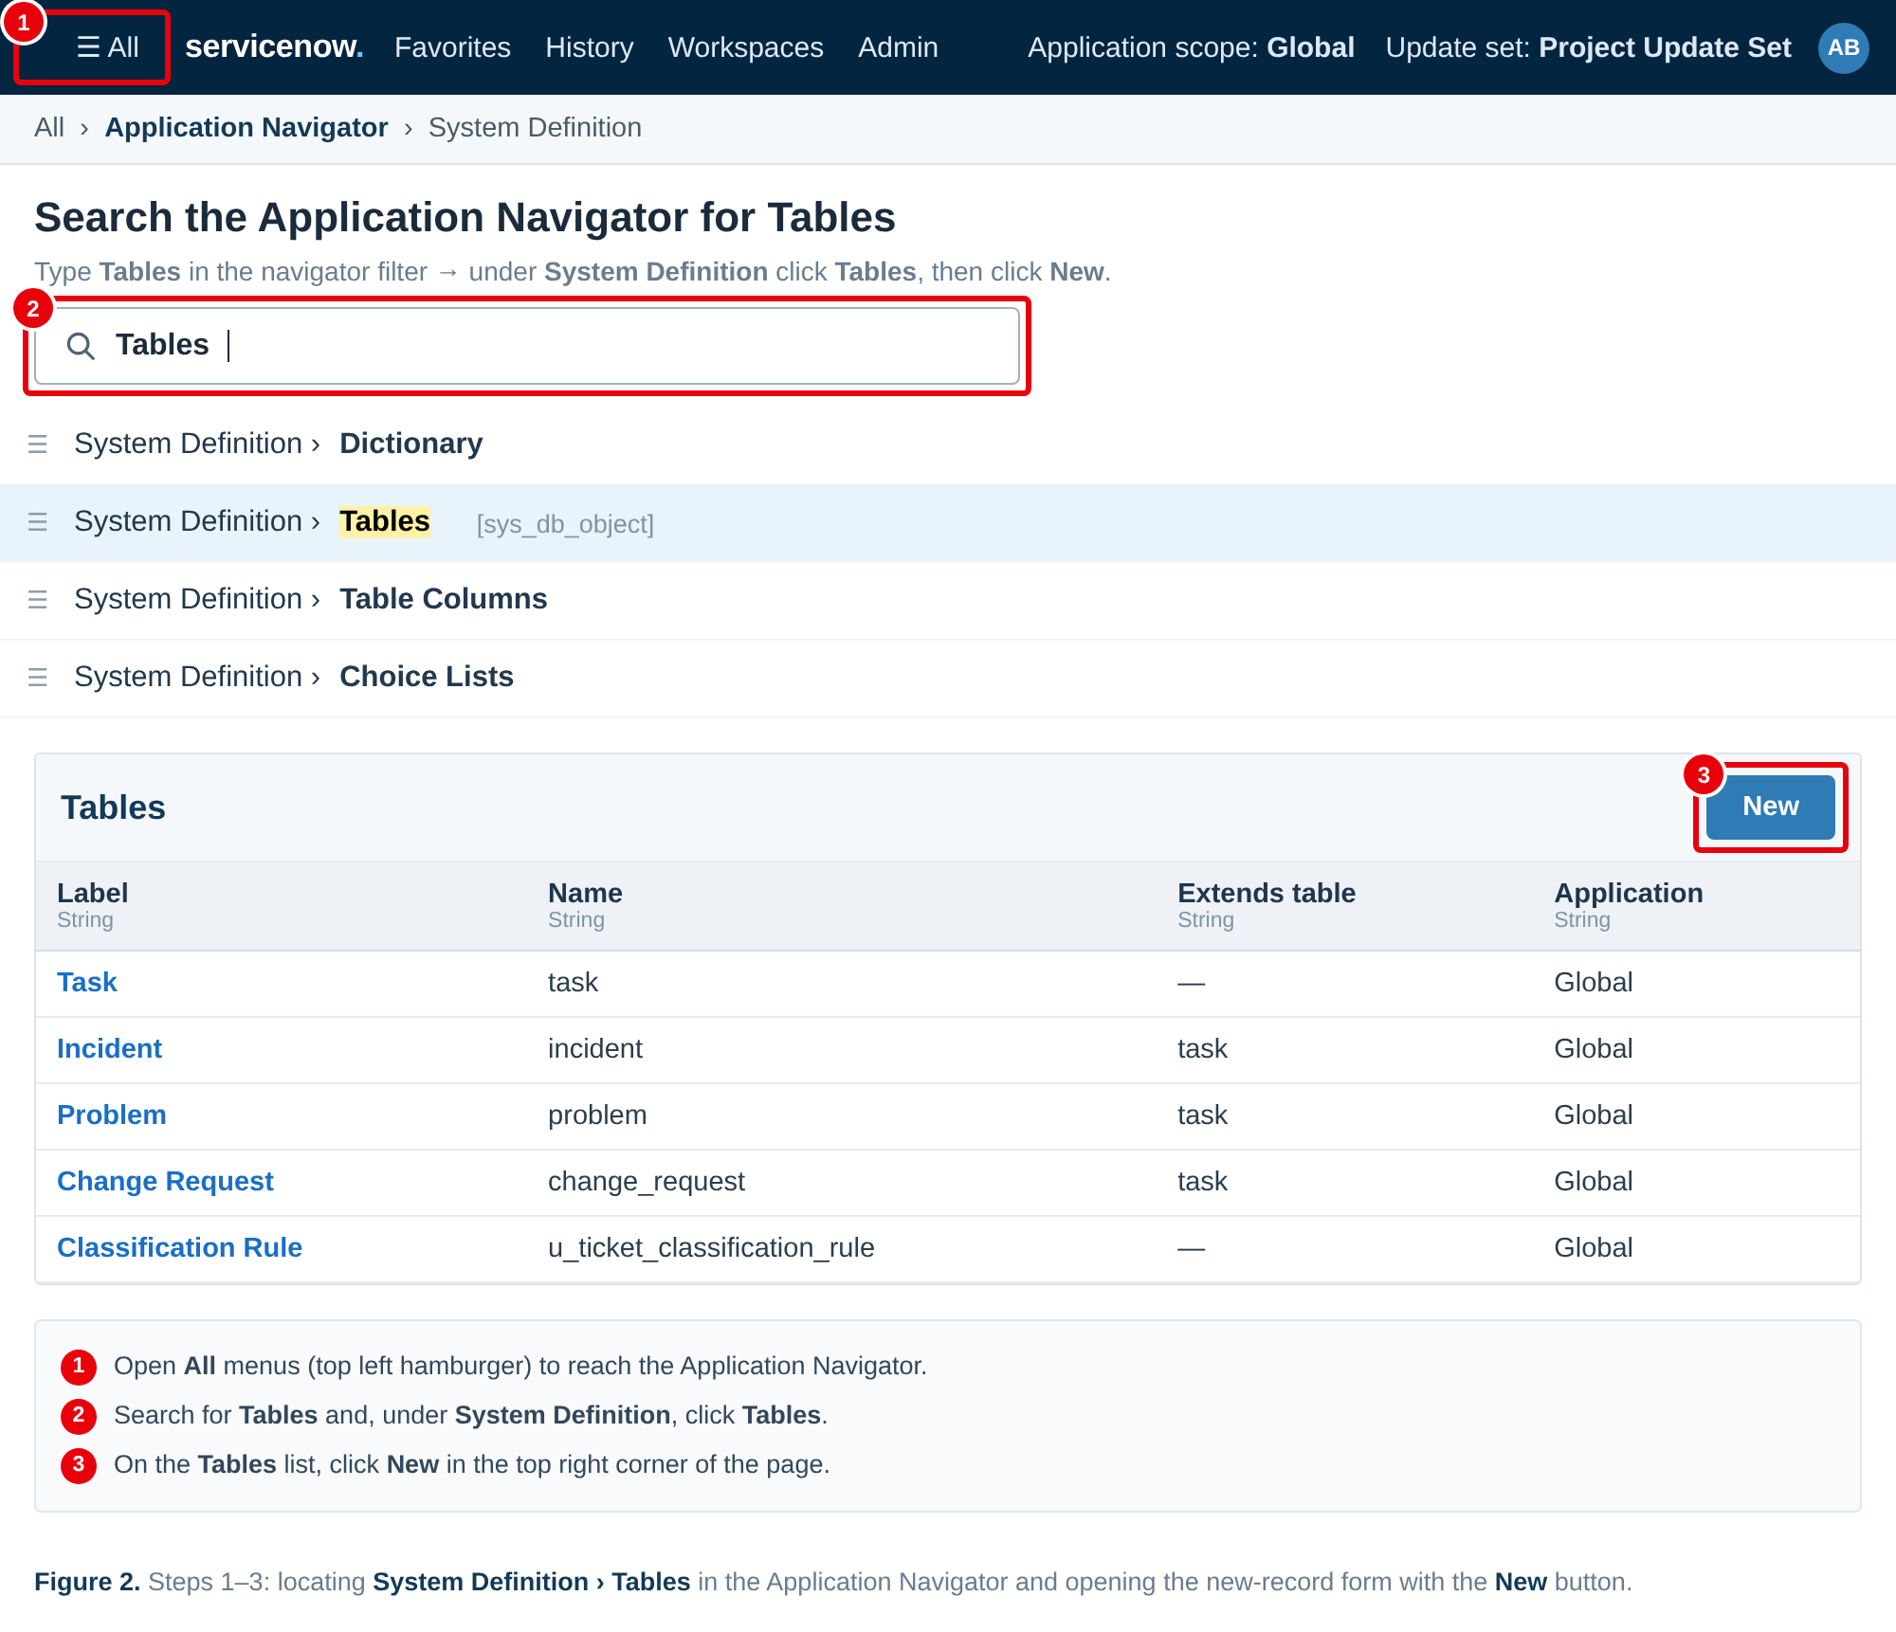
Figure 2. Steps 1–3: opening All menus, searching for Tables in the Application Navigator, and clicking New on the Tables list.
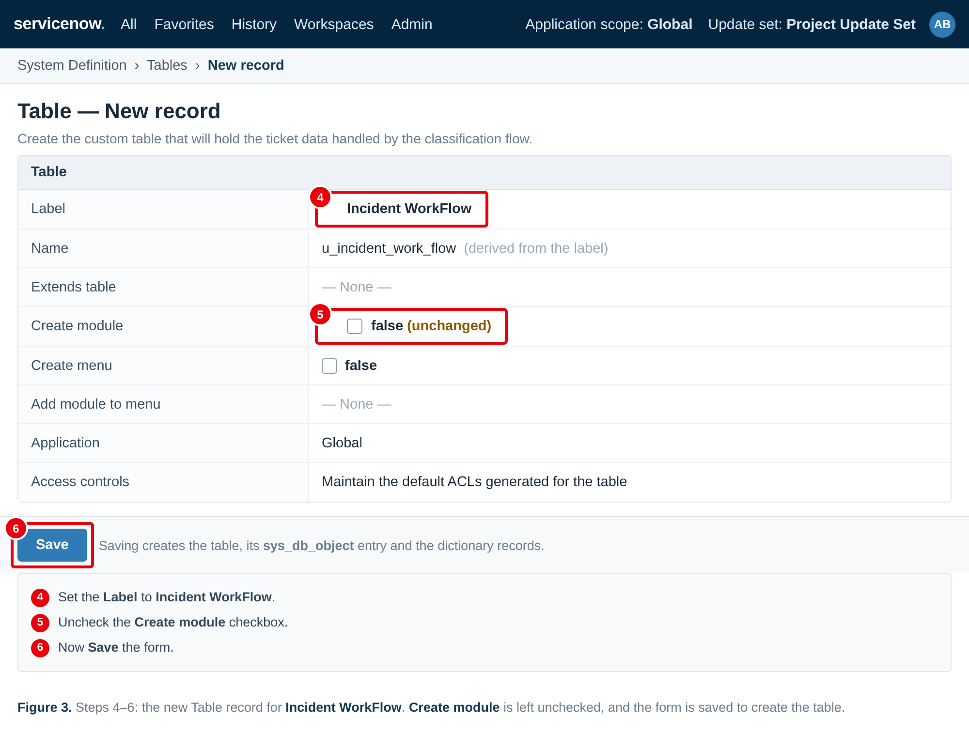
Figure 3. Steps 4–6: naming the table Incident WorkFlow, leaving Create module unchecked, and saving the form.
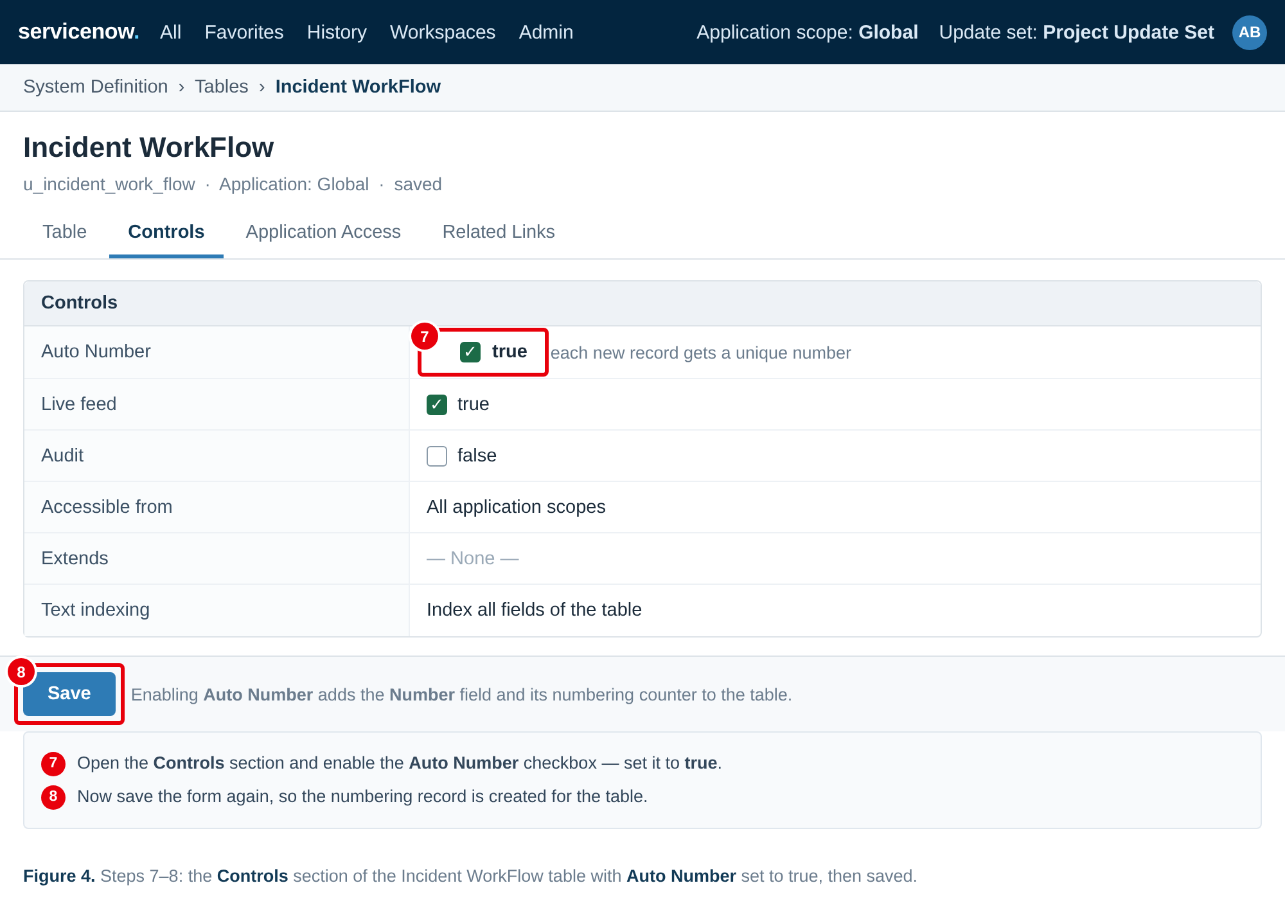
Figure 4. Steps 7–8: enabling Auto Number to true in the Controls section, then saving the form again.
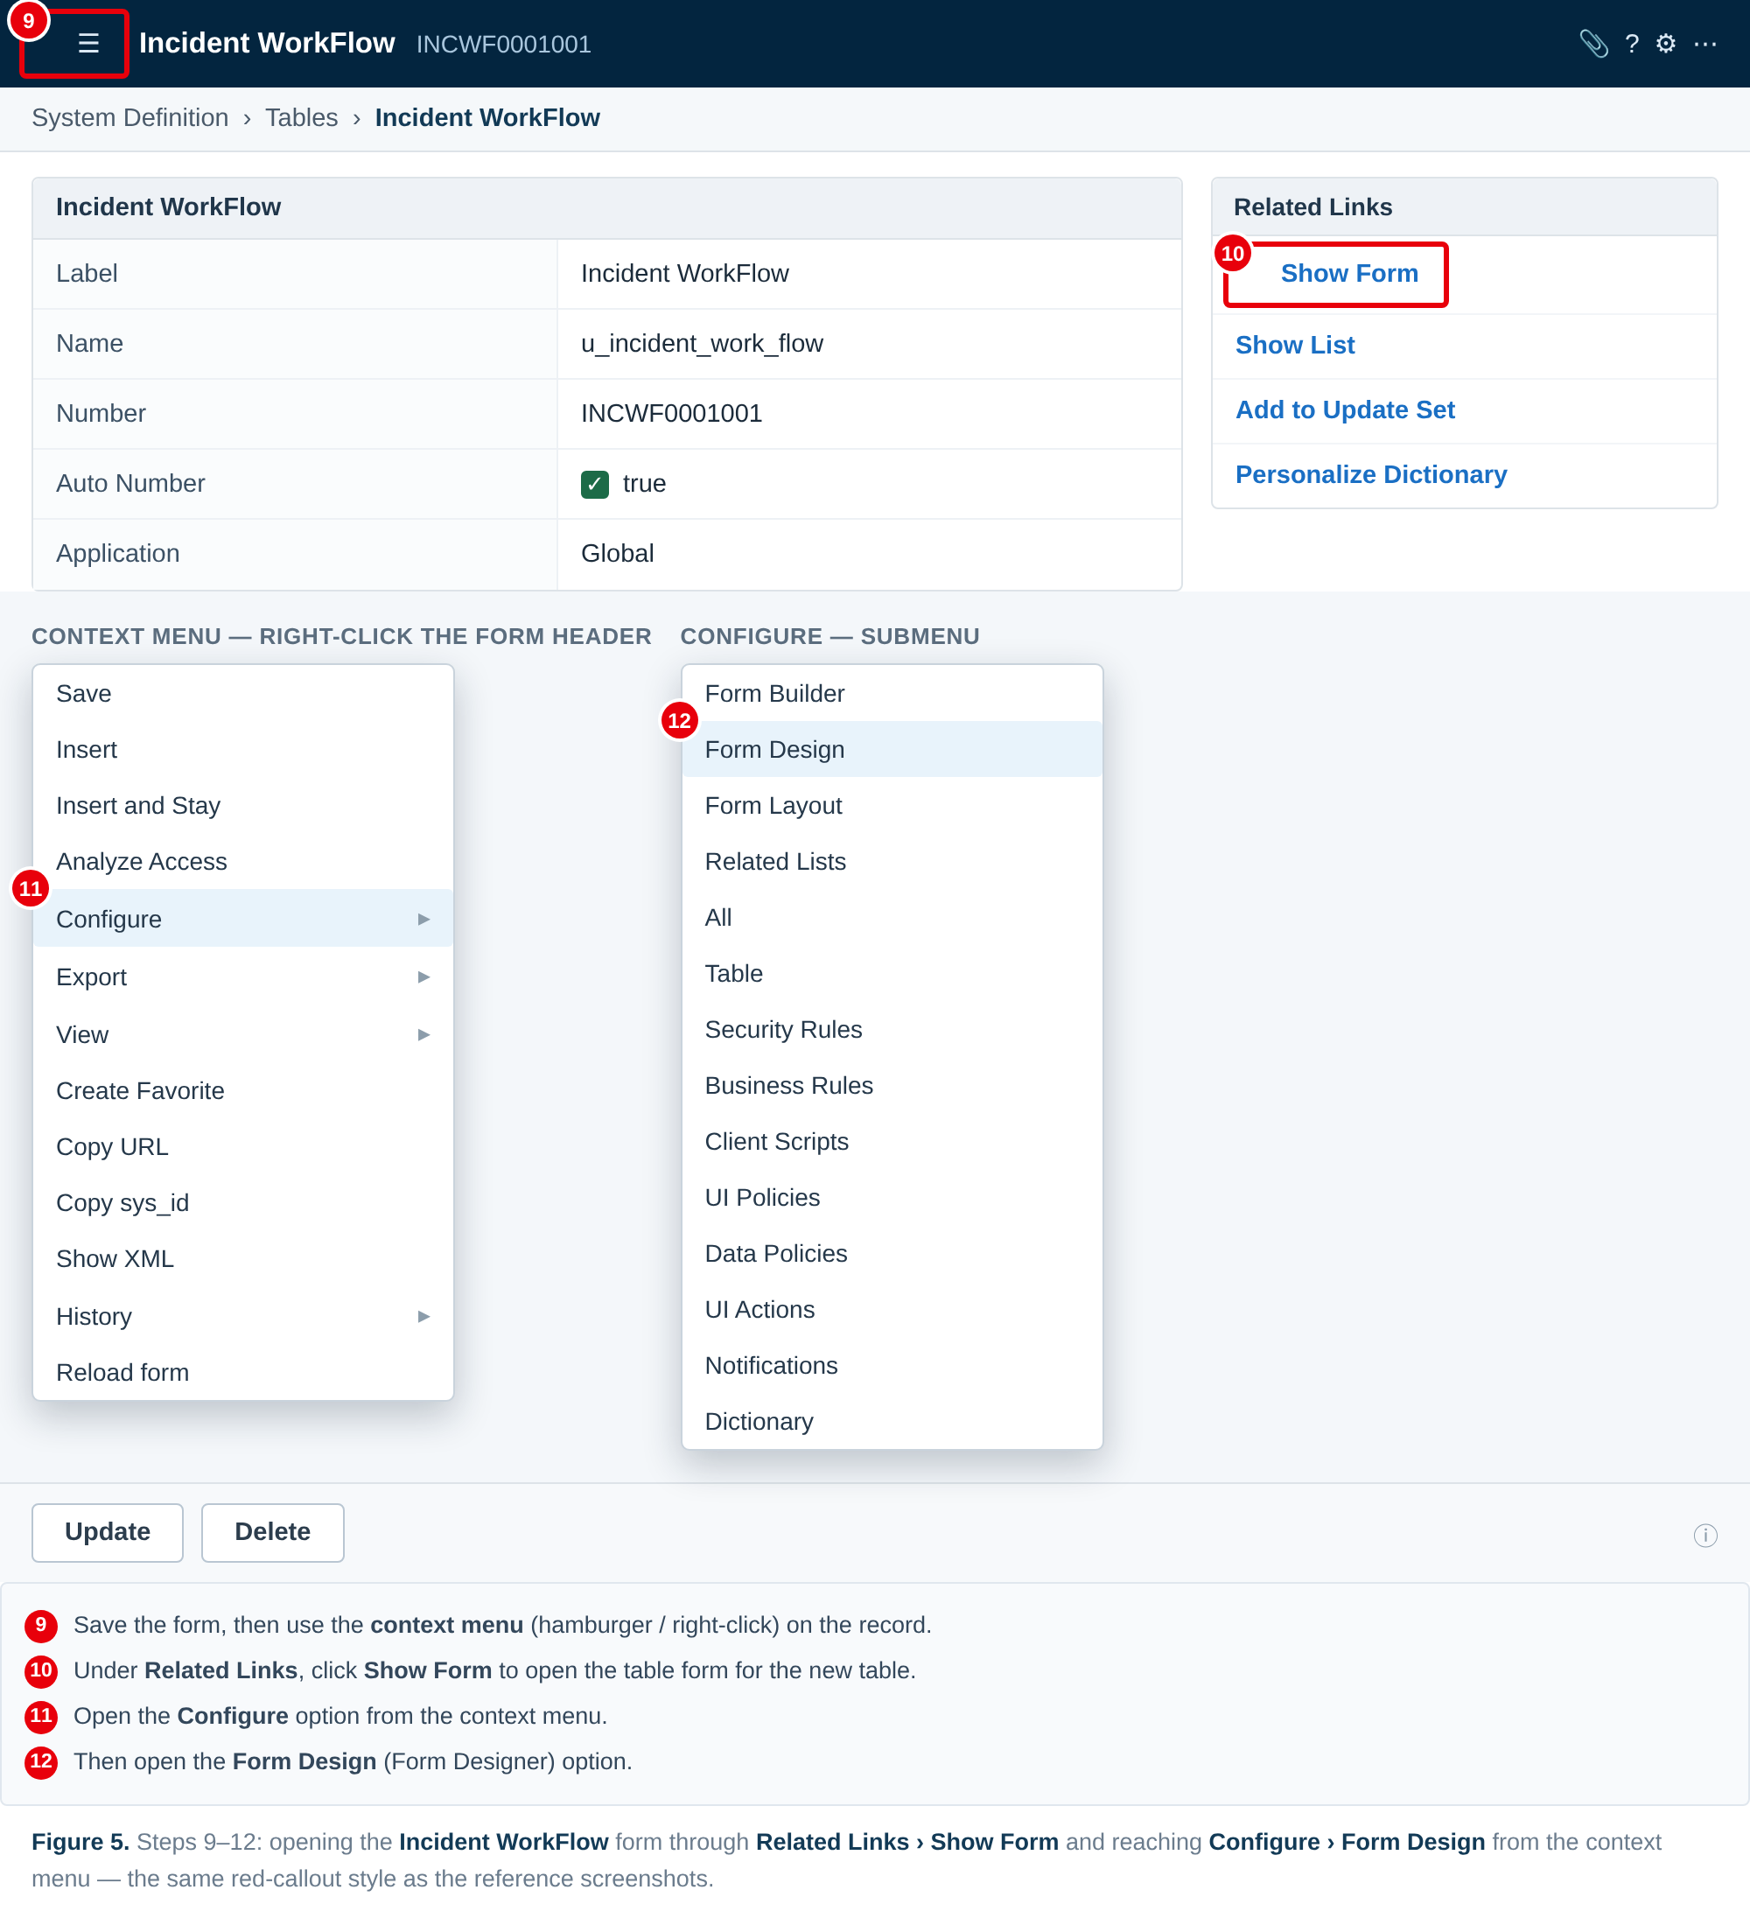
Figure 5. Steps 9–10: opening the form through Related Links → Show Form and reaching Configure → Form Design from the context menu.
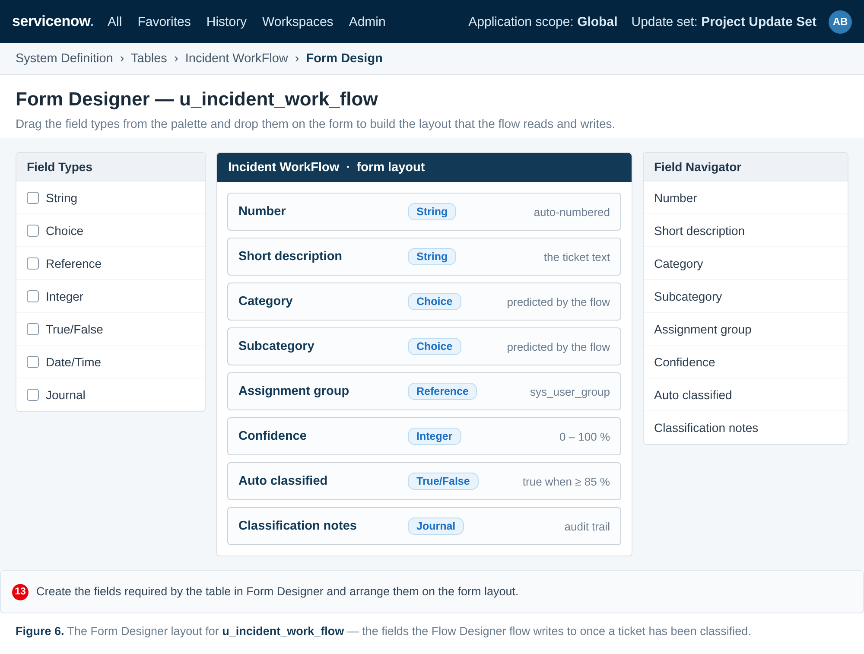
Figure 6. Step 11: the Form Designer layout for u_incident_work_flow, with the fields the classification flow reads and writes.
Once the table and its fields exist, the Flow Designer flow is built against them: the flow triggers on record creation, looks up the classification rules, predicts the category and assignment group, and writes the result back to Category, Subcategory, Assignment group and Confidence on this table.
References:
https://www.servicenow.com/docs/bundle/zurich-application-development/page/build/flow-designer/concept/flow-designer.html
https://www.servicenow.com/docs/bundle/zurich-platform-administration/page/administer/table-administration/concept/c_CreatingCustomTables.html
https://www.servicenow.com/docs/
https://developer.servicenow.com/dev.do
https://c4model.com/
https://aws.amazon.com/architecture
https://medium.com/the-internal-startup/how-to-draw-useful-technical-architecture-diagrams-2d20c9fda90d

